# **User Help**

**Installation**

To get started with Visual Studio Code (VSCode), you need to install it on your machine.

1. Download: Visit he official website at https://code.visualstudio.com/ and download the appropriate version for your operating system (Windows, Linux, or Mac).
2. Install: Run the installer and follow the step-by-step instructions. The default settings are usually appropriate for most users, but feel free to customize them according to your needs.

**Setting Up Your Project**

After installing VSCode, you can start using it for your project. Here are the steps to set up your project in VSCode:

1. Opening a Project: To open your project in VSCode, go to File -> Open Folder from the top left menu. Navigate to your project's directory, select it, and click OK. This action will import your project into VSCode and you can view the project files in the Explorer view on the left side(Fig31.).

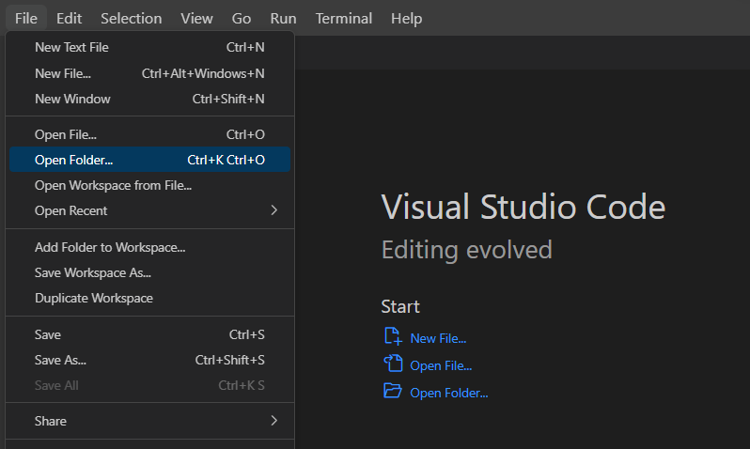

Fig.31:Visual Studio → File

1. Installing Extensions: Depending on your project's programming language, you might need to install some extensions. Extensions are additional tools that enhance the functionality of VSCode. For our project, if your project is in Python, you might want to install the Python extension developed by Microsoft for better code linting, syntax highlighting, and debugging. To install an extension, click on the Extensions view icon (four squares) on the Activity Bar, search for the desired extension (like "Python"), and click Install.
2. Opening a Code File: You can open any file from your project by clicking on it in the Explorer view. The file will open in a new tab in the editor window.
3. Running Code: To execute the code, right-click anywhere in the code file and select Run Python File in Terminal (if your code is in Python). This will open the Integrated Terminal at the bottom of VSCode and run your code. If you're using a different language, the process is similar, though the exact context menu item might be different.

**Using the Project**

Now that you've set up your project in VSCode, you can start using it. Here's how you can run different parts of the project:

1. Importing Data: Put your dataset into the Data folder. This folder should be in the root directory of your project.
2. Executing Notebook: you can execute all the cells by clicking on the “Run All” button. This button is typically located at the top of the notebook interface.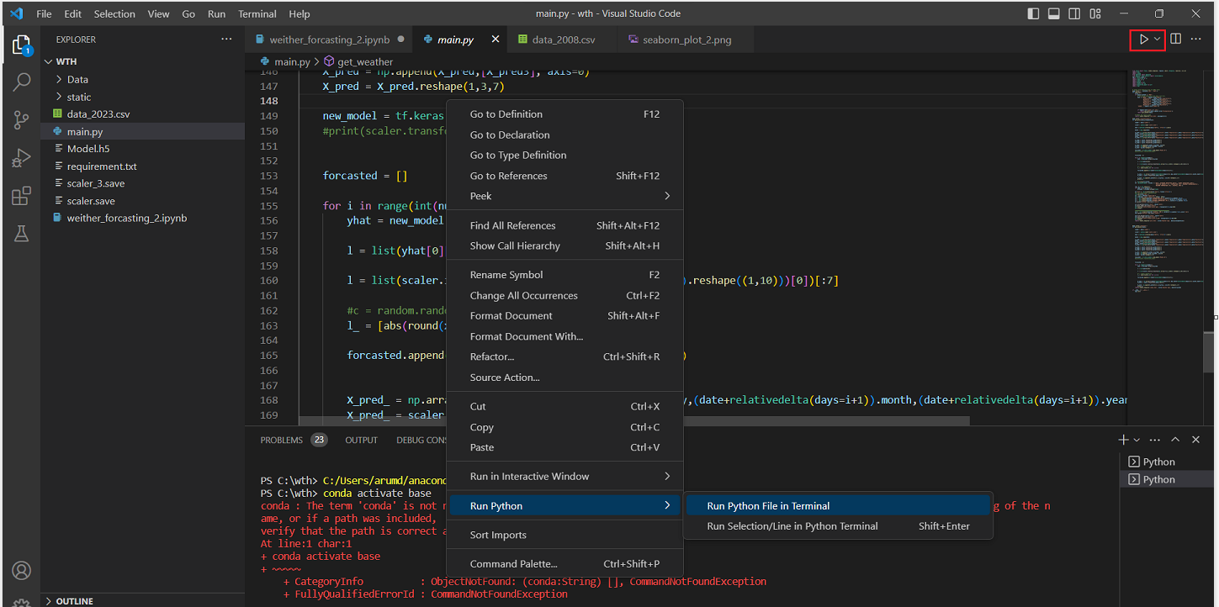

Fig.32:Right Click Mouse Button in Visual Studio Code

1. Launching the User Interface: You can launch the user interface by running the main.py file. To do this, right-click anywhere in the main.py file and select Run Python File in Terminal, or click the “Run” button(in red).
2. After running main.py, the Integrated Terminal will display the following output(Fig.32): Running on http://127.0.0.1:5000

Press CTRL+C to quit.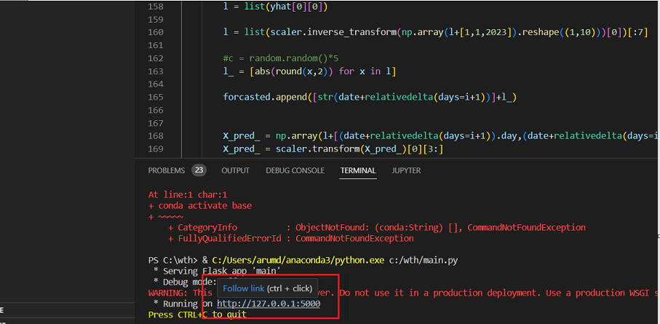

Fig.33:Integrated Terminal

This output signifies that the user interface is running on your local machine. You can access it by opening your web browser and navigating to <http://127.0.0.1:5000> which will display the web flask app.